**H0= there is no relationship between attitude and purchase intention**

**data=read.csv(file.choose())**

**str(data)**

'data.frame': 119 obs. of 24 variables:

$ Age : int 1 1 1 1 1 3 1 1 1 1 ...

$ Gender : int 2 2 1 1 1 2 1 1 2 1 ...

$ Education : int 5 5 4 5 5 5 5 5 5 5 ...

$ Income : int 4 1 1 1 2 3 1 2 4 1 ...

$ Place.of.Residence : int 1 1 1 1 1 1 3 1 1 1 ...

$ Monthly.expenditure.on.OTC.medicines. : int 2 1 4 1 1 5 5 1 1 1 ...

$ Are.you.suffering.from.any.common.illness. : int 1 2 1 1 2 1 1 1 2 1 ...

$ PI_V1 : int 3 2 2 2 1 1 1 3 2 2 ...

$ PI_V2 : int 3 3 3 4 3 3 2 2 2 3 ...

$ PI_V3 : int 3 2 2 2 2 2 2 2 2 2 ...

$ PI_V4 : int 3 2 1 1 1 1 1 2 2 2 ...

$ PI_V5 : int 3 2 3 4 3 2 2 4 2 4 ...

$ PI_V6 : int 3 2 1 2 1 3 1 2 1 2 ...

$ PI_V7 : int 3 1 3 2 2 2 2 2 1 3 ...

$ PI_V8 : int 3 2 2 1 2 1 2 3 1 2 ...

$ AT_V3 : int 3 2 3 3 2 2 3 2 2 3 ...

$ AT_V2 : int 2 2 2 3 2 3 2 3 2 2 ...

$ AT_V1 : int 3 1 3 3 3 3 3 3 3 3 ...

$ AT_V3.1 : int 1 1 1 1 1 1 1 1 1 1 ...

$ Do.you.suffer.from.any.side.effect.of.OTC.medicine. : int 2 2 3 2 2 2 3 3 1 2 ...

$ Have.you.used.any.vitamins.or.other.dietary.supplements.in.the.past.year.: int 1 2 1 2 2 2 2 3 2 1 ...

$ Do.you.have.any.long.term.disease..Diabetes..BP..Asthma.. : int 2 2 2 2 2 2 1 2 2 2 ...

$ PI : int 24 16 17 18 15 15 13 20 13 20 ...

$ AT : int 9 6 9 10 8 9 9 9 8 9 ...

**> m1=lm(PI~AT,data = data)**

**> print(m1)**

Call:

lm(formula = PI ~ AT, data = data)

Coefficients:

(Intercept) AT

15.795 0.241

**> summary(m1)**

Call:

lm(formula = PI ~ AT, data = data)

Residuals:

Min 1Q Median 3Q Max

-10.2049 -2.7049 -0.4818 2.9156 12.0362

Coefficients:

Estimate Std. Error t value Pr(>|t|)

(Intercept) 15.795 2.948 5.358 4.28e-07 ***

AT 0.241 0.318 0.758 0.45

---

Signif. codes: 0 ‘***’ 0.001 ‘**’ 0.01 ‘*’ 0.05 ‘.’ 0.1 ‘ ’ 1

Residual standard error: 4.336 on 117 degrees of freedom

Multiple R-squared: 0.004885, Adjusted R-squared: -0.00362

F-statistic: 0.5744 on 1 and 117 DF, p-value: 0.45

**> r= cor(data$AT,data$PI)**

**> r**

[1] 0.06989613

**> plot(PI~AT,data=data)**

**> abline(m1,col="red")**

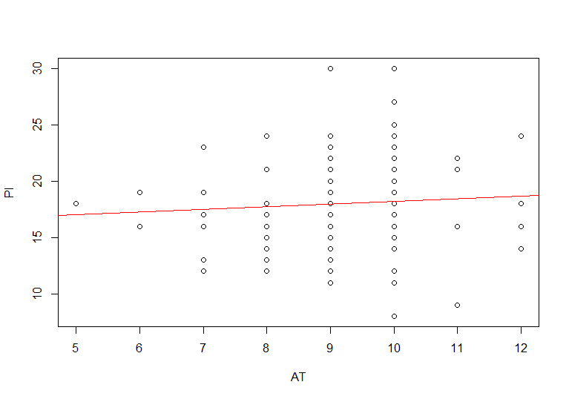

**Conclusion-** we got p- value = 0.45 which is greater than 0.05 hence we do not reject null hypothesis and conclude that there is no effect of Attitude on purchase intention

> cor.test(data$Income,data$Monthly.expenditure.on.OTC.medicines., method="spearman")

Spearman's rank correlation rho

data: data$Income and data$Monthly.expenditure.on.OTC.medicines.

S = 281915, p-value = 0.967

alternative hypothesis: true rho is not equal to 0

sample estimates:

rho

-0.003827857

**Descriptive statistics**

| **Age** | | | | | |
| --- | --- | --- | --- | --- | --- |
|  | | Frequency | Percent | Valid Percent | Cumulative Percent |
| Valid | 20-29 | 102 | 85.7 | 85.7 | 85.7 |
| 30-39 | 6 | 5.0 | 5.0 | 90.8 |
| 40-49 | 8 | 6.7 | 6.7 | 97.5 |
| 50 above | 3 | 2.5 | 2.5 | 100.0 |
| Total | 119 | 100.0 | 100.0 |  |

| **Gender** | | | | | |
| --- | --- | --- | --- | --- | --- |
|  | | Frequency | Percent | Valid Percent | Cumulative Percent |
| Valid | male | 52 | 43.7 | 43.7 | 43.7 |
| female | 67 | 56.3 | 56.3 | 100.0 |
| Total | 119 | 100.0 | 100.0 |  |

| **Income** | | | | | |
| --- | --- | --- | --- | --- | --- |
|  | | Frequency | Percent | Valid Percent | Cumulative Percent |
| Valid | 0-1 lakh | 63 | 52.9 | 52.9 | 52.9 |
| 1-5 lakh | 18 | 15.1 | 15.1 | 68.1 |
| 5-10 lakh | 30 | 25.2 | 25.2 | 93.3 |
| 10 lakh above | 8 | 6.7 | 6.7 | 100.0 |
| Total | 119 | 100.0 | 100.0 |  |

| **Education** | | | | | |
| --- | --- | --- | --- | --- | --- |
|  | | Frequency | Percent | Valid Percent | Cumulative Percent |
| Valid | Primary | 1 | .8 | .8 | .8 |
| Secondary | 2 | 1.7 | 1.7 | 2.5 |
| Higher secondary | 4 | 3.4 | 3.4 | 5.9 |
| Graduation | 60 | 50.4 | 50.4 | 56.3 |
| Post graduation | 51 | 42.9 | 42.9 | 99.2 |
| other | 1 | .8 | .8 | 100.0 |
| Total | 119 | 100.0 | 100.0 |  |

| **PlaceofResidence** | | | | | |
| --- | --- | --- | --- | --- | --- |
|  | | Frequency | Percent | Valid Percent | Cumulative Percent |
| Valid | urban | 84 | 70.6 | 70.6 | 70.6 |
| rural | 13 | 10.9 | 10.9 | 81.5 |
| semi-urban | 22 | 18.5 | 18.5 | 100.0 |
| Total | 119 | 100.0 | 100.0 |  |

| **Monthly expenditure OTC medicines** | | | | | |
| --- | --- | --- | --- | --- | --- |
|  | | Frequency | Percent | Valid Percent | Cumulative Percent |
| Valid | below 200 | 72 | 60.5 | 60.5 | 60.5 |
| 200-400 | 30 | 25.2 | 25.2 | 85.7 |
| 401-600 | 6 | 5.0 | 5.0 | 90.8 |
| 601-800 | 4 | 3.4 | 3.4 | 94.1 |
| 800 above | 7 | 5.9 | 5.9 | 100.0 |
| Total | 119 | 100.0 | 100.0 |  |

| **Are You Suffering From Any Common Illness** | | | | | |
| --- | --- | --- | --- | --- | --- |
|  | | Frequency | Percent | Valid Percent | Cumulative Percent |
| Valid | 1 | 52 | 43.7 | 43.7 | 43.7 |
| 2 | 42 | 35.3 | 35.3 | 79.0 |
| 3 | 16 | 13.4 | 13.4 | 92.4 |
| 4 | 4 | 3.4 | 3.4 | 95.8 |
| 5 | 5 | 4.2 | 4.2 | 100.0 |
| Total | 119 | 100.0 | 100.0 |  |

**H0= There is no relationship between education and AT_V3 (i.e taking self medication without reading instruction)**

**> m1=lm(AT_V3 ~ Education,data = data)**

**> summary(m1)**

Call:

lm(formula = AT_V3 ~ Education, data = data)

Residuals:

Min 1Q Median 3Q Max

-0.4744 -0.3225 -0.1706 -0.1706 1.8294

Coefficients:

Estimate Std. Error t value Pr(>|t|)

(Intercept) 1.9302 0.3128 6.171 1.01e-08 ***

Education -0.1519 0.0709 -2.143 0.0342 *

---

Signif. codes: 0 ‘***’ 0.001 ‘**’ 0.01 ‘*’ 0.05 ‘.’ 0.1 ‘ ’ 1

Residual standard error: 0.5546 on 117 degrees of freedom

Multiple R-squared: 0.03776, Adjusted R-squared: 0.02953

F-statistic: 4.591 on 1 and 117 DF, p-value: 0.03421

**Conclusion- here pvalue=0.03<0.05 hence we rej null hypothesis and conclude that there is effect of education on AT_V3**